3/10/2021

TEBOHO MOSUHLI

BOTHO UNIVERSITY

Computing Project

Lesotho Blood Bank Management System (LBBM)

Contents

Chapter 1 Project Proposal 3

1.1. Introduction 3

1.2. Background 3

1.3. Problem Statement 4

1.4. Proposed Solution 4

1.5. Aims and Objectives 4

1.5.1 AIMS 4

1.5.2 OBJECTIVES 4

1.6. Project Scope 5

1.7. Ethical Consideration 5

Chapter 2 Literature Review 6

2.1. Existing System 6

2.2. Research Methodology 6

2.2.1. Incremental Model System Development Life Cycled 7

2.2.2. Methodology Justification 7

2.3. Resource Requirements 8

2.4. Functional Requirements 8

2.4.1 Non-Functional Requirements 8

2.5. Modeling Diagrams 9

2.5.1 Use Case 9

2.5.2 Activity Diagrams 10

2.6. Project Plan 11

Chapter 3 12

3.1 Class Diagram 12

3.2 Sequence Diagram 13

3.3 Object/Communication Diagram 14

3.3 State Chart Diagram 15

Chapter 4 Final Project 16

4.1 Testing 16

4.1.1 Donor 16

4.1.2 Organization 20

4.1.3 Admin 23

4.1.4 Staff 30

4.2 Evaluation 34

# Chapter 1 Project Proposal

## Introduction

In today’s every day’s life, we come across many emergency situations such as accidents which cause bleeding and loss of blood. Such issues create an immediate critical need for supply of blood of specific blood type as per the requirements of one who is in need. In addition to emergency requirements, advances in medicine have increased the need for blood in many on-going treatments and elective surgeries. The online Blood Bank Management system is to create an e-Information about the donor and organization that are related to donating the blood. The proposed solution shall incorporate a website. The website links all blood banks in order to know about the required quantity resulting in the ease of access for customers.

## 1.2. Background

A blood bank is a central repository in which blood id stored and managed as a result of blood gathered by collection and donation which are preserved for future use in blood transfusion. There are numbers of online web based blood bank management system existing for storage of data for blood centers and hospitals to maintain information of donors, blood available, as well as transaction information. Recent research on this topic shows that manual systems as compared to computer based information system are time consuming, laborious and costly. In this project, I have introduced a new solution blood bank management which is called the Lesotho Blood Bank Management System (LBBMS). With this system, donors and other recipients such as patients and hospitals can register into the system. Donors will be able to access information about the various blood banks registered to the system as well as blood donation campaigns organized by blood banks. The blood banks are added into the system by the administrator. Recipients (Patients, Hospitals, Clinics, etc.) will also have access to important information like blood type that are available and at which blood center.

There is no centralized database of volunteer donors. So, it becomes really tedious for a person to search blood in case of emergency. The only options to manually search and match donors and then make phone calls to every donor. This is also no centralized database used to keep the donor’s records. Each bank is having their own records of donors. If donor makes donation in different hospital, no previous records can be traced except if the donor brings along the donation certificate. Hence, the donor is considered to be a first-timer if they make blood donation in a new place.

Without an automated management system, there are also problems in keeping track of the actual amount of each and every blood type in the blood bank.

## Problem Statement

At present, public can only know about the blood donation events through conventional media means such as radio, newspaper or television advertisements. These is no information regarding the blood donation programs available on any of the portal. The current system that is using by the blood bank is manual system, with this system (Manual System), there are problems in managing the donor’s records. The records of the donor might not be kept safety and there might be missing of donor’s records due to human error or disasters. Besides that, errors might occur when the staff keeps more than one record for the same donor.

In addition, there is also no alert available when the blood quantity is below its par level or when the blood in the blood bank has expired.

## Proposed Solution

The system is used for maintaining all the process and activities of blood bank management system.

The system can be extended to be used for maintain records of hospital, organ donation and other similar sectors. While developing the system, there shall be space for further modification. There shall be proper documentation so that further enhancement becomes easy.

As a whole the system is focused to work with blood bank management system and on additional modification it can be also used as management systems of systems of similar organizations.

## Aims and Objectives

### 1.5.1 AIMS

To build a solution to the ever growing requirement of blood supply due to accidents and various health problems.

To access the information about various blood banks and hospitals in order to know about their blood stock of various blood groups.

### 1.5.2 OBJECTIVES

To automate the complete operations of the blood bank.

To maintain thousands of blood bank records.

To search for blood of the required blood group and get the required type through this website.

To be used by the blood banks or blood centers as a mean to advertise the nationwide blood donation events to the public and allow the hospitals to make request for the blood.

To allow users to donate and keep the donors information and blood stock in the blood bank.

## Project Scope

The proposed web-based application will act as an interface between users and database, the database will store user’s account details, the blood group details and all necessary details. The system will allow users like hospitals and clinics to request blood from blood bank.

Tasks to be carried out in order to complete the project:

* Processes should be authentically managed.
* The design of the interfaces Should be analyzed.
* Implement the blood bank information to the web application.
* Verify that the clients accept all deliverables and they are satisfied.
* Deliver project.

Tasks not to be tackled by the web application are:

* It will not allow any users to request blood except clinics and hospitals.
* It will not allow to donate without registering

## Ethical Consideration

Just Deliberation is simply the declaration that there will be no data loss or disclosure of any information during the data collection time. I assure that the participants assisting on carrying out this project will not be revealed to anyone and the information got from them will be kept confidential during the research moment. There will be strict expertise and no participant will be made painful anyhow.

# Chapter 2 Literature Review

The purpose of this research is to find a way to implement a system that will provide a solution not only to blood centers but also to the numerous patients and willing blood donors. To do so, I have made a lot of research as to find out how people have solved this problem.

In order to make this research successfully, I have to analyze the current state and how blood bank operate.

## 2.1. Existing System

A number of researches have written on this concept of blood bank management systems with the majority of them praising computerization as a mechanism of achieving efficiency and effectiveness in this area thus not looking at some problems that system may face due to limited or misuse of functionalities.

The proposed development of an information management system that manage blood bank based on the information of donor, recipient and blood bank (Esah & Ab Rahman, 2011). Their system has 3 modules, which are donor, patient and blood module. However, some vital issues are left aside in the approach, for example their system does not show who is responsible for managing the users and blood in the blood bank store using this system.

(Gaijjart, 2002) suggests a development of blood bank data management system as a solution to prevent near miss events and improve record retrieval. Their argument is that with computerized fast and easy recovery of records will improve productivity of blood banks processes.

According to (Khanter, 2009) a management information system application that covers some of the blood bank management issues related to a particular region. Additionally, (Mohammad, 2012) came up with and interesting method which is the supply of chain for blood and blood products terming processes irregularly and the demand of blood stochastic. This will be great implementation if and only if blood bank management will be effective.

Lastly, (Ekanayaka, 2015) developed a blood Bank Management system that will help blood bank to gather the donors details into one place automatically and tells them about opportunities to donate, this message is passed using SMS and donors will receive the message on his/her phone.

## 2.2. Research Methodology

Below is the diagram that shows the incremental model is chosen in developing this project. This model has been selected because project can be developed through cycle of phase. The development of the project is that it must follow the phase that is a phase at a time. If there is any correction, it can be done in the middle of the process. Incremental model included five phases which are requirement analysis, design, implementation and unit testing, integration and system testing and operation.

### 2.2.1. Incremental Model System Development Life Cycled

Requirements

Designs

Implementation and Unit Testing

Integration and System Testing

Operation

### 2.2.2. Methodology Justification

This model (Incremental model) is chosen to develop this project because of these some factors:

1. Flexibility

This model allows changes that happen in the middle of the process, the system still can be implemented and proceed so that all the modules that want to be achieved are success.

1. Saves time

As the system that is developed using cyclic model, the development of the project can be continuously done although there are some errors in the middle of the process.

1. Security

This model is more organized and easy to understand the flow

## 2.3. Resource Requirements

The project will be developed using certain hardware and software, the minimum hardware will include the PC of processor Intel inside and 2 GB Ram. This will speed up the PC so that it will allow the development to run smoothly.

The Software will include windows 10 operating system, Visual Studio 2015 for interface design, SQL Server for database storage, ASP.NET Framework. The language that will be used is C#.

## 2.4. Functional Requirements

* Event confirmation
* Notified for events
* Vote for an event: going/may be
* View upcoming events
* Event calendar
* Publicity for an event through medias
* View donation history
* Statistical representation of data (annual/monthly reports)

### 2.4.1 Non-Functional Requirements

* Security Requirements

1. Role based access control
2. Data encryption using security mechanism

* Localized web Browser (mobile/PC)

## 2.5. Modeling Diagrams

### 2.5.1 Use Case

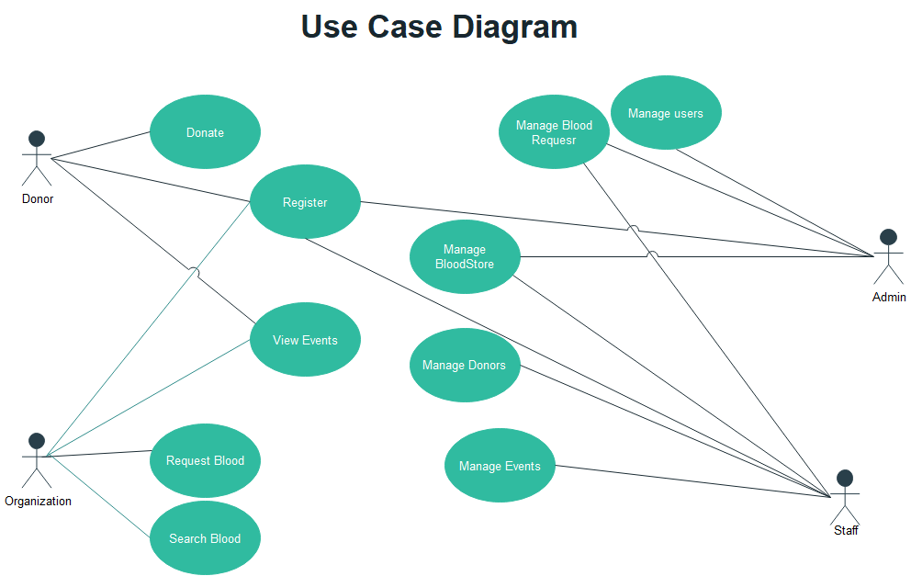

This is the use case diagram for my system, it only shows users and their tasks, all users should register before accessing the system, donor can also view events made by blood bank for donations. Lastly, he/she can donate blood as to become a well know donor. Admin can manage blood request from hospitals or clinics, he can approve the blood request if the requested blood available in the store or he can reject the request if the blood not available at that moment. Admin can also update, delete or register other users (staff members). Lastly, he can manage blood store.

Staff members can also manage events donors and blood store, this means that staff members can update, delete and add on these three modules. An Organization can view upcoming and previews events, request blood from blood bank and search a donor where if donor is available he/she can call him or her to donate foe a patient in the clinic or hospital.

### Activity Diagrams

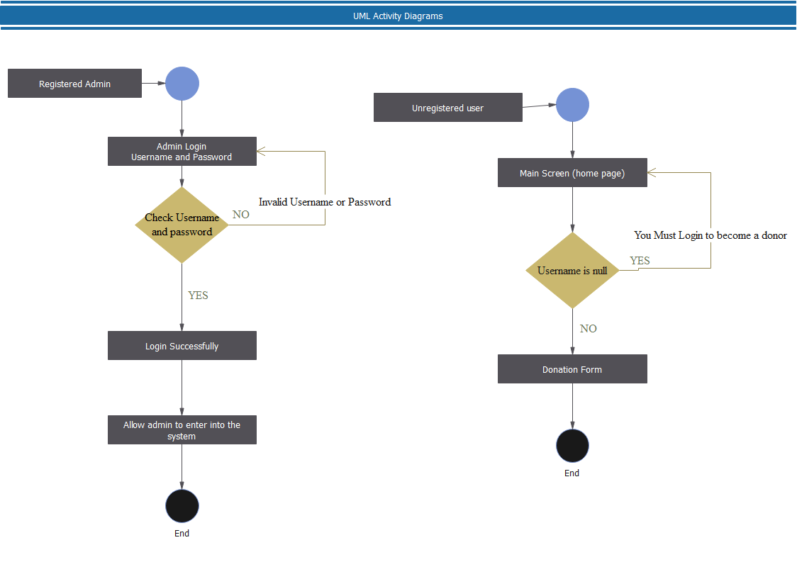

This is an activity diagrams, the first one shows that registered admin login, if username or password is incorrect, the popup message will show and user will be allowed to click ok and return to the login page. If the username and password are correct the popup message will show and the user will be taken to their respective home page according to their roles. The second shows user entering in to the system and donate blood, if user did not login, he or she will be taken to login and allow him or her to login first, will make life easy because when user has logged in same details that are needed to donate will be taken from database and user does not need to re-enter the details like blood group and others.

## 2.6. Project Plan

|  |  |  |  |
| --- | --- | --- | --- |
| Task Name | Duration | Start | Finish |
| PROJECT PROPOSAL | 27 days? | Mon 2/8/21 | Tue 3/16/21 |
| LITERATURE(FIRST) REVIEW | 11 days? | Tue 3/16/21 | Tue 3/30/21 |
| SECOND REVIEW | 16 days? | Tue 3/30/21 | Tue 4/20/21 |
| ARTIFACT TESTING, EVALUATION, CONCLUSION | 11 days? | Tue 4/20/21 | Tue 5/4/21 |
| FINAL PROJECT PRESENTATION | 4 days? | Wed 5/5/21 | Sat 5/8/21 |
| REPORT SUBMISSION ON TURNITIN | 1 day? | Tue 5/11/21 | Tue 5/11/21 |

# Chapter 3

## 3.1 Class Diagram

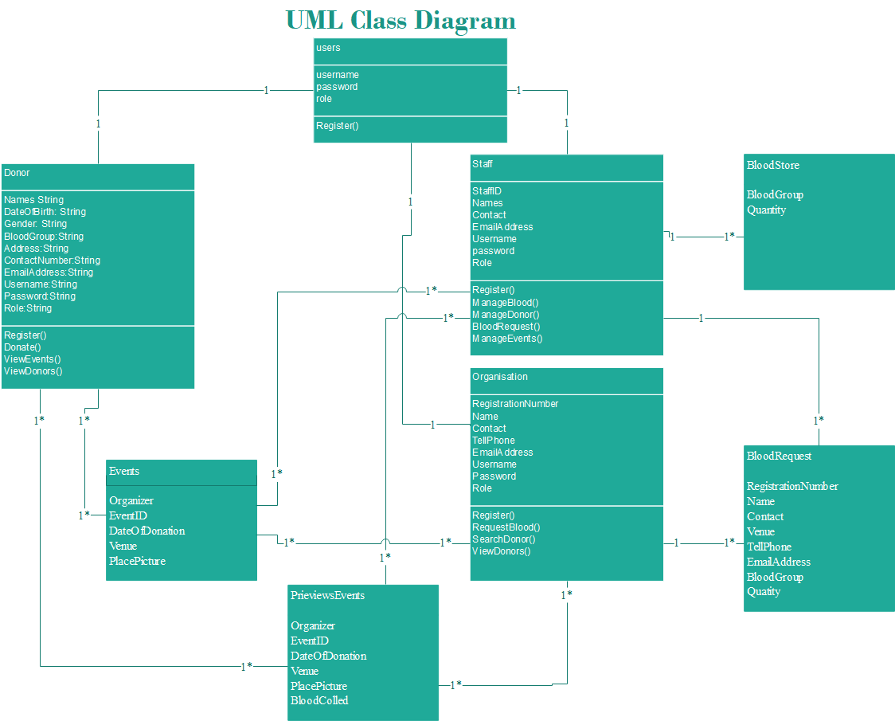

This is the class diagram that shows how tables are related and which user is access to a specific table, like user staff have access to events, he/she can add, update and/or delete events. Also, staff can manage Blood store and blood request from organizations that works with people that may need a blood. Lastly, user staff can manage previews events. A donor can view events (Upcoming or Previews events), view other donors. Viewing of events for donor helps blood bank as, if user sees that there is going being to be a blood donation at nearby place, he/she can go there and volunteer to donate blood.

## 3.2 Sequence Diagram

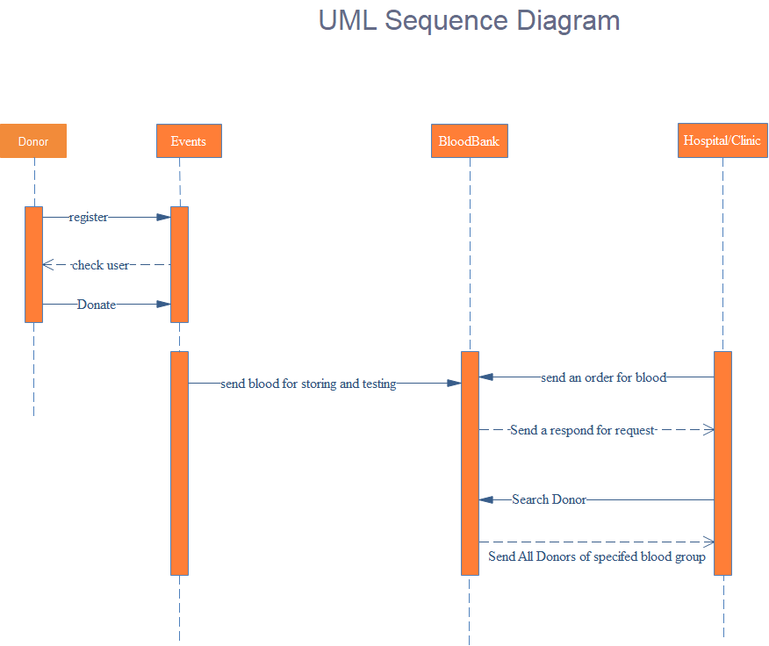

This sequence diagram shows that the user donor can register and donate at the events and blood is taken to blood bank store for testing and storing. It also shows that hospital or clinic can send blood order from blood bank and it will receive response from blood bank. The responses are, either blood will be delivered or the requested blood is not available in the store. In some times where hospital needs blood directly from the donors near the hospital, the hospital can search donors that are nearby directly in blood bank database and make a phone, the donor can be go to hospital and helps the person who need blood.

## 3.3 Object/Communication Diagram

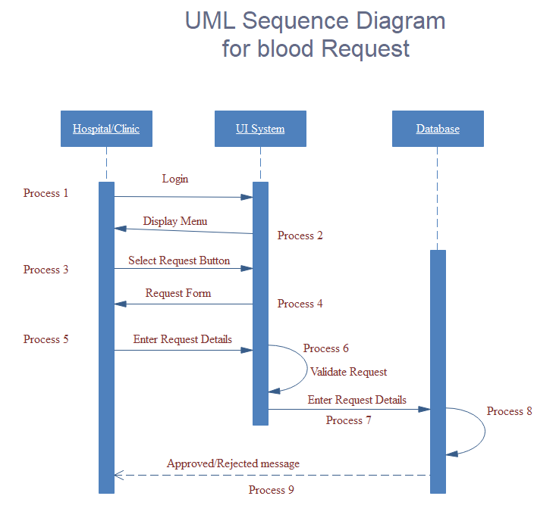

This one shows how user communicate with the system from when he login and clicks the request blood button and filling the form for request up until he receives the responses from the blood bank. If the blood requested by hospital or clinic available in the blood bank store, the message will show that the blood will be delivered to that organization or an organization will be asked to go and take the blood according to the agreement between the blood bank and organization else if blood not available, the system response message will show that the blood is not available in the store.

## 3.3 State Chart Diagram

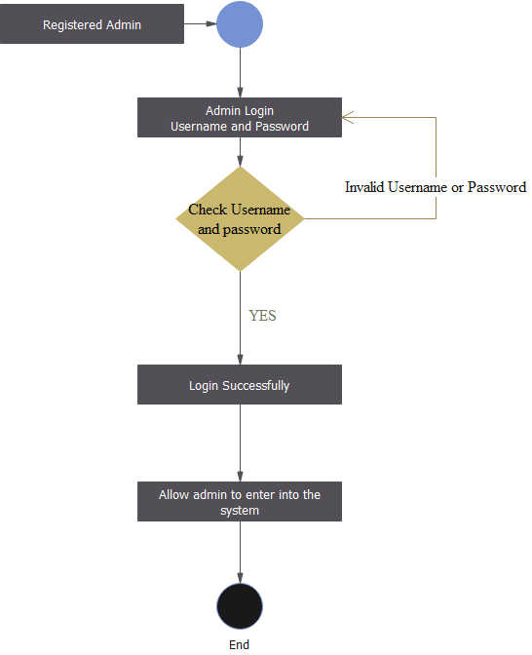

# Chapter 4 Final Project

## 4.1 Testing

### 4.1.1 Donor

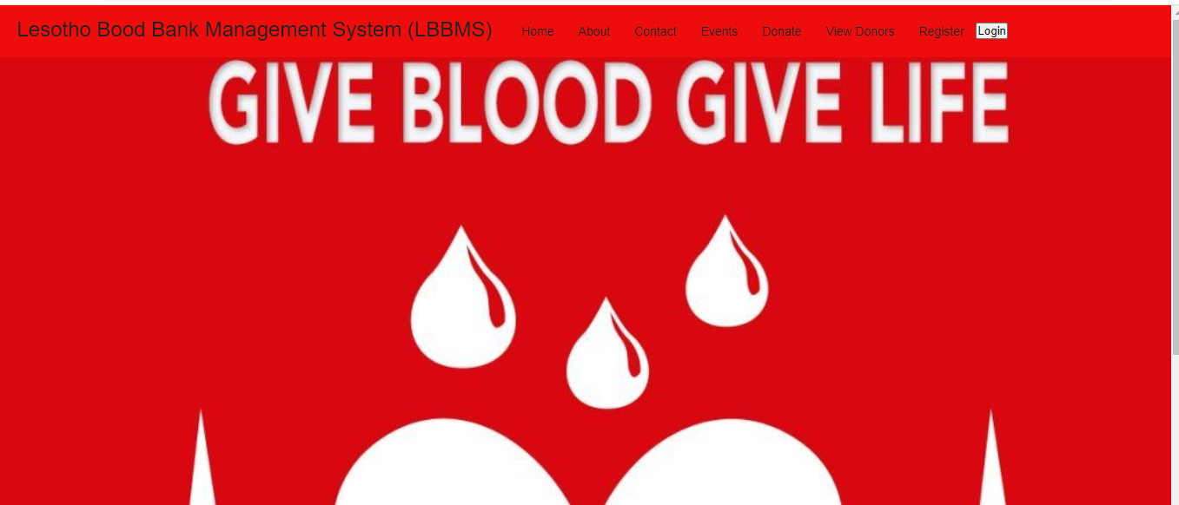

The above screenshot shows an index for Lesotho blood bank management system, it shows that user can view events, Donate, view donors, register and lastly login. The user before donating should register and login as to become a user.

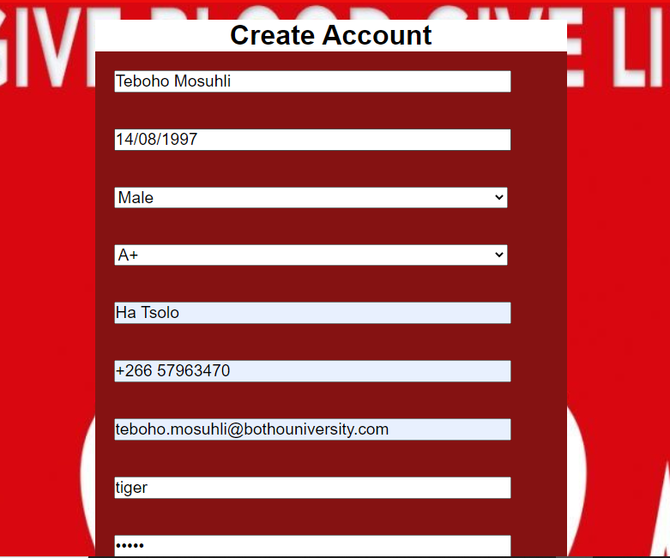

Here, the user is registering as an individual(Donor) user. The user after registering he/she will get notification from his/her email that shows registration success.

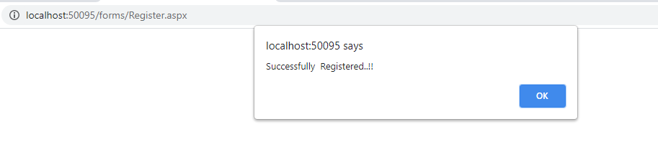

Here, I have used JavaScript to show user has successfully registered.

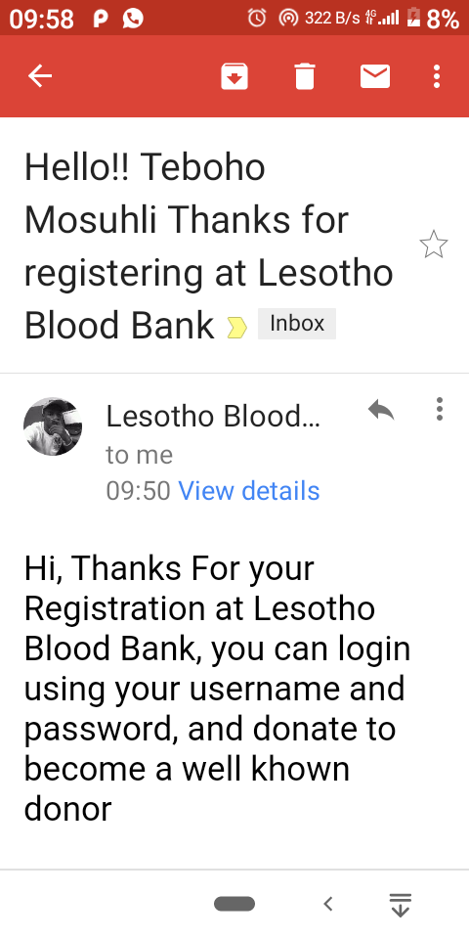

This is an email received by donor after Registration.

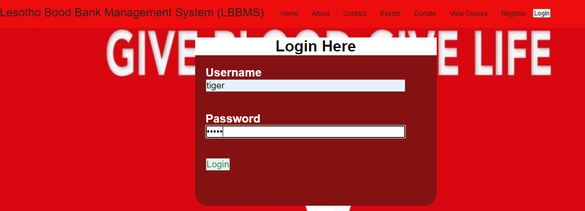



After user has successfully registered, he/she can now login using entered username and password when registering and the pop-up message will appear that shows that user successfully logged in. when user click enter or OK he/she will be taken to home page for donors.

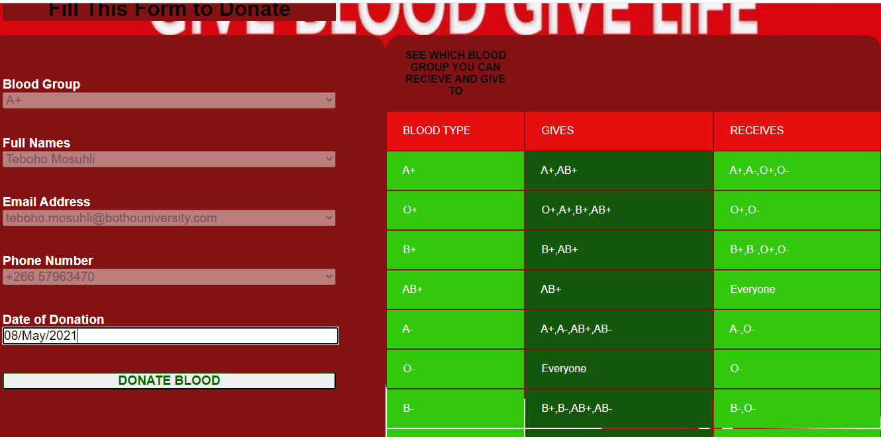

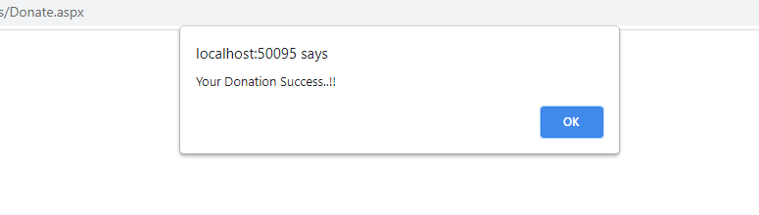

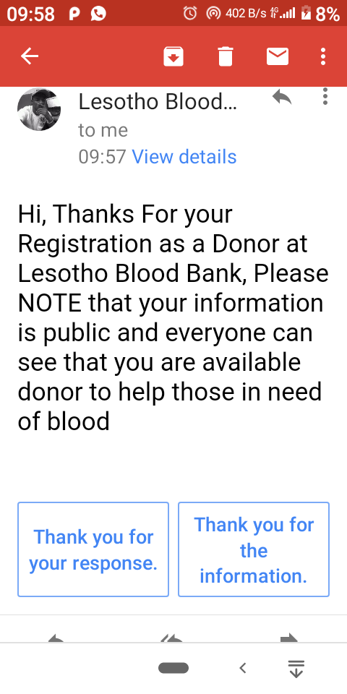

This one shows the user donating as to become a well-known donor. This can only happen when donor have logged in first as the Blood group and other details except date of donation are taken using session and the message will pop-up that shows the user has successfully donated. When user donate also an email is send that shows that donation is success.

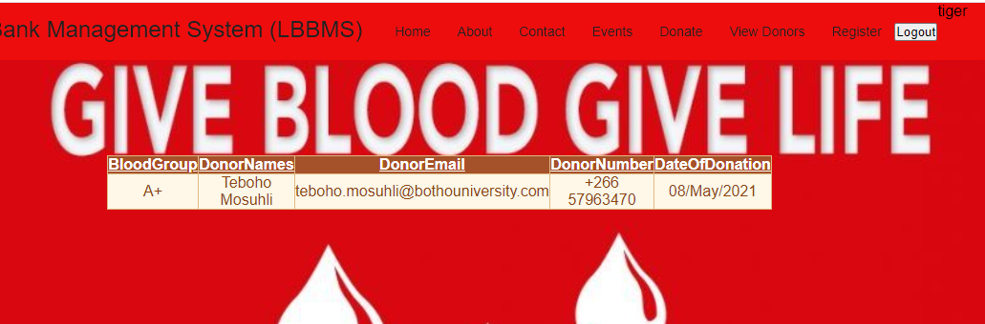

When user tiger clicks on view donor, all available donors will be displayed on the screen, now only one user has already donated.

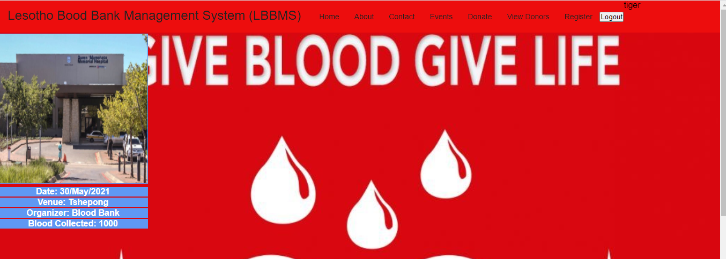

The user can also view previews events

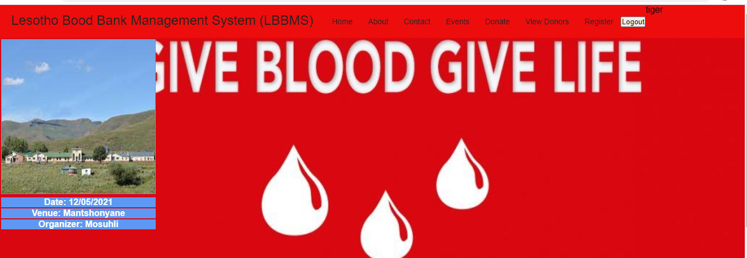

The user tiger viewed upcoming events, this can help a donor to see where event is taking place and the date, if it’s a nearby place, the user can go and donate blood.

### 4.1.2 Organization

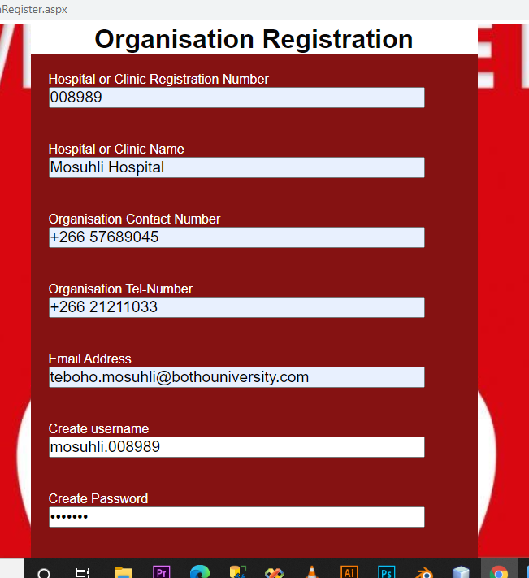

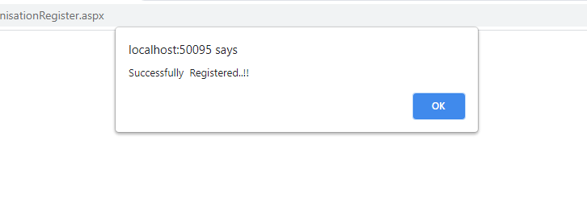

The above screenshots show an organization (Hospital or Clinic) registering and the message will pop-up to show that registration success. This helps organization to create account that they will use to request blood and search donor.

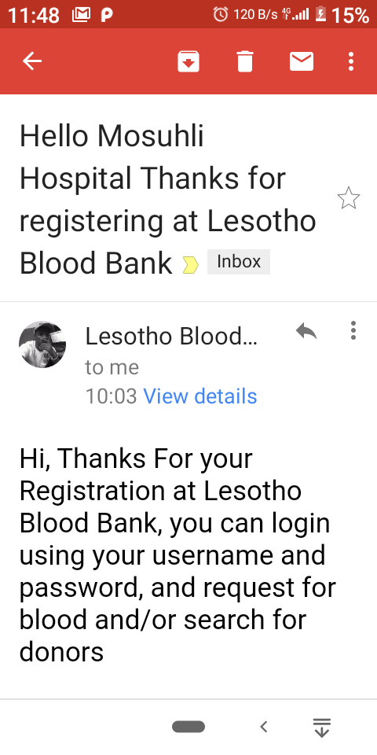

This is an email that an organization receive after registration, this is just a prove that the registration is success.

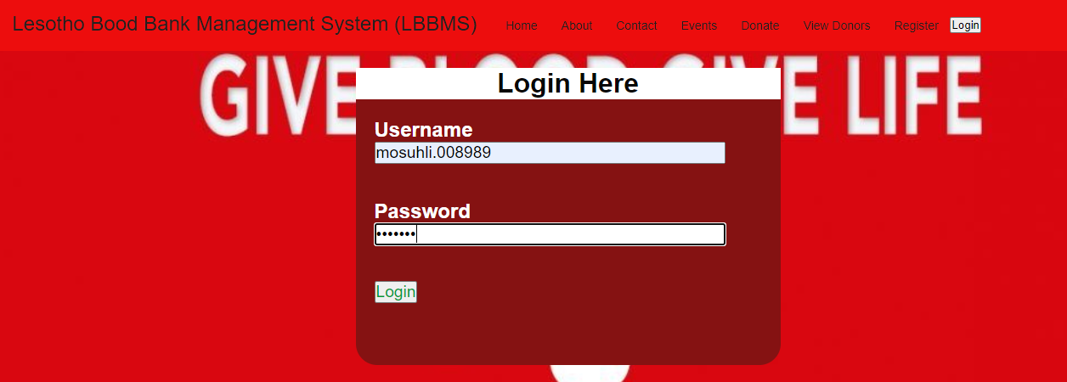

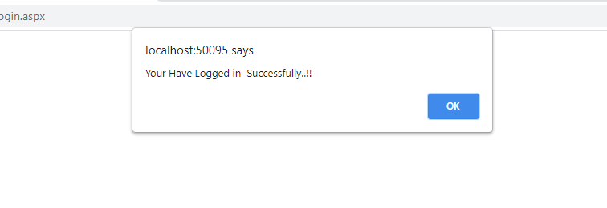

An organization after registration, it can log in. This is a login used by all users but the role will determine whether user is a donor, Admin, blood bank Staff or an organization and the message shows that login success.

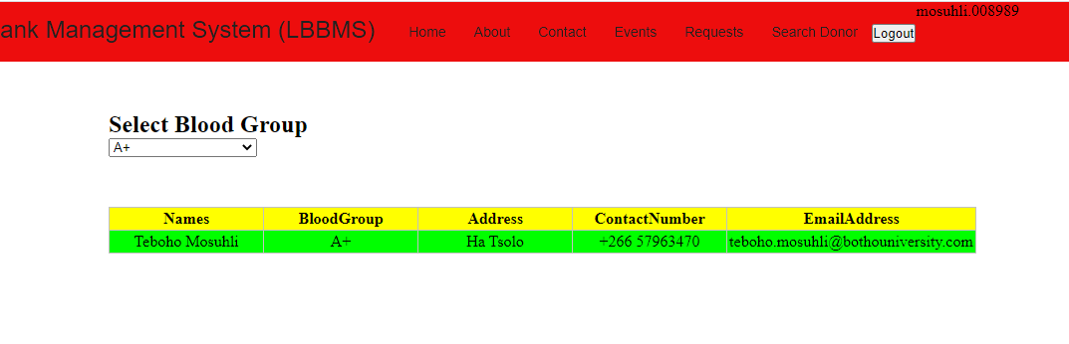

An organization can search for a donor using blood group, this helps an organization to find nearby donor if the is an emergency of blood in clinic or hospital and blood need not available in their store.

An organization can call or email a donor to visit them to donate blood.

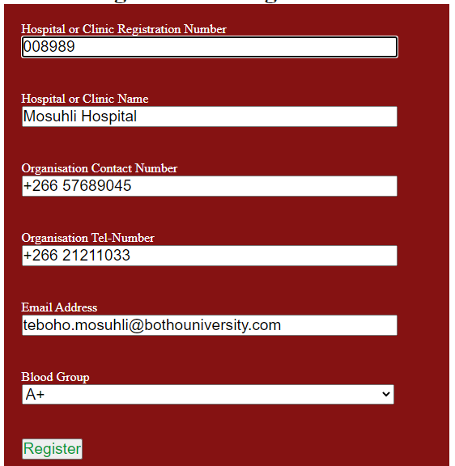

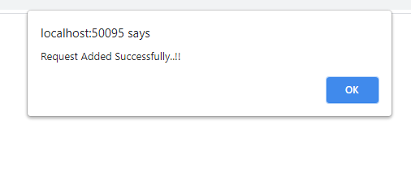

In addition, the organization can request blood from blood bank and specify which blood they requesting. The details are taken from database because the user already registered and the only field that need to be filled is blood group.

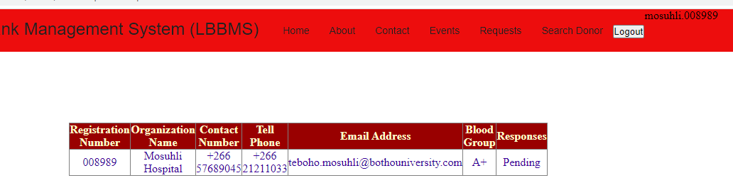

An organization can also view their request whether they are pending, rejected or approved.

### 4.1.3 Admin

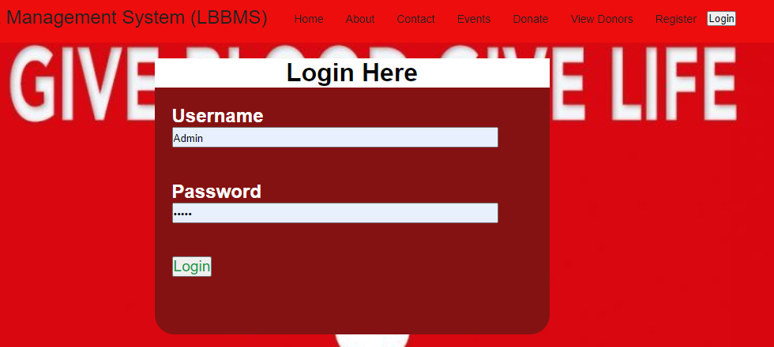

This system has user admin which is inserted manually in the database, this user can login and add other blood bank users which can be staff or admin only. This is an login showing user admin lagging in.

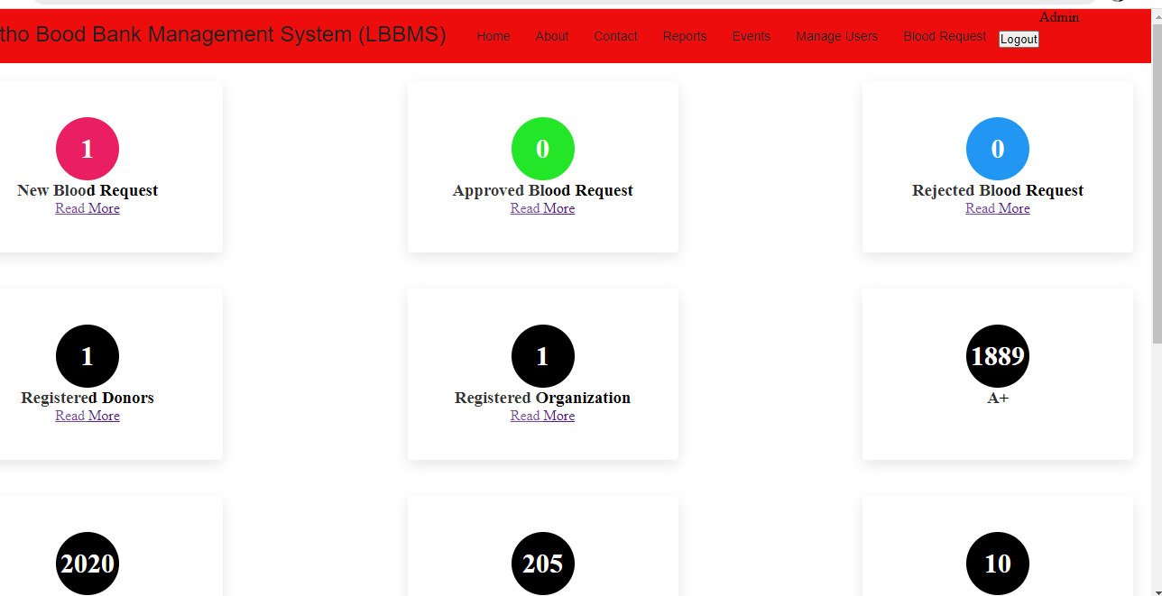

This is welcome page for admin, it shows new blood request, approved blood request, rejected blood request and registered donors and organization, lastly it shows available blood in their store.

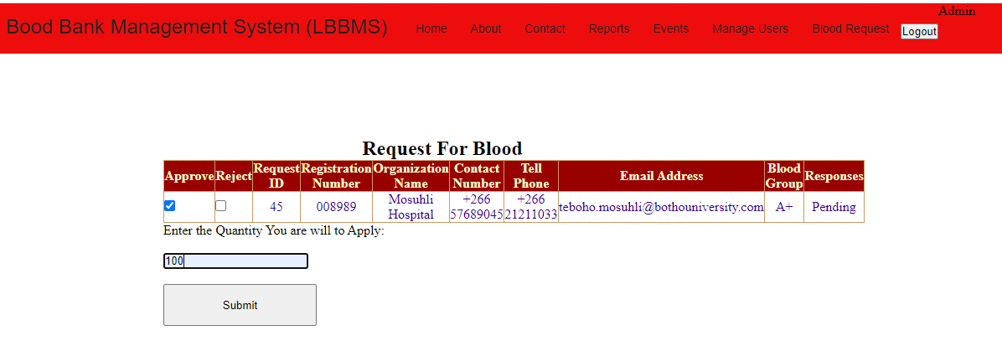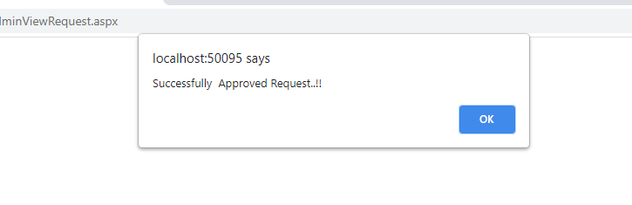

This is the screenshot showing admin approving the blood request, an admin have to enter the quantity they can give to an organization and the blood will be decreased by the entered quantity.

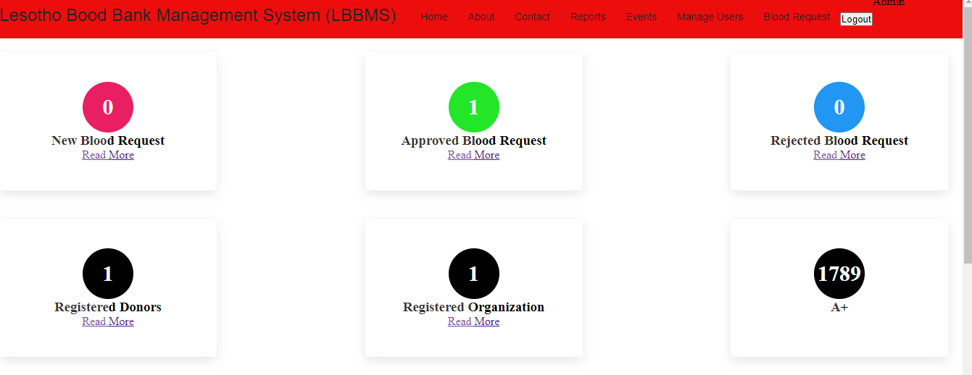

This screenshot shows that the blood group of type A+ its now 1789 not 1889, this shows that there is 100 units that has been taken out.

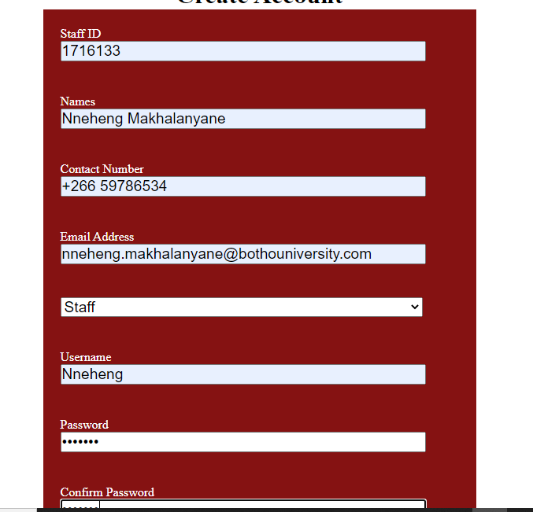

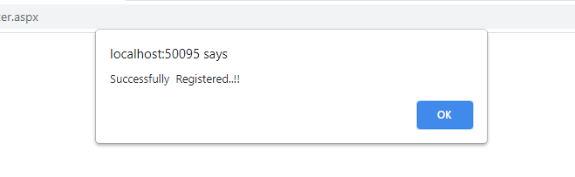

This shows an admin registering a staff member into the system.

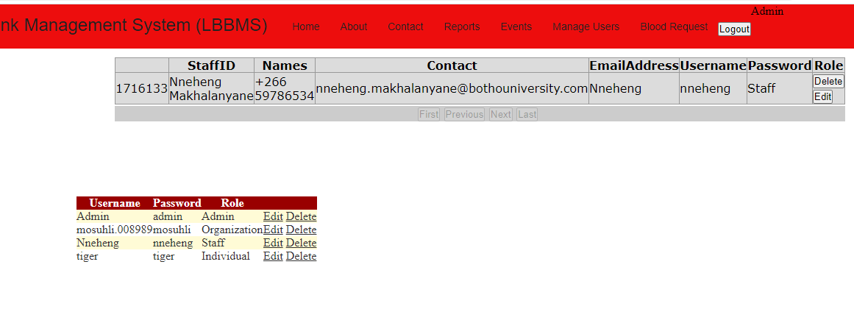

The first table on the screenshot shows staff members of the blood bank and the second table shows user accounts, here admin can update and/or delete users.

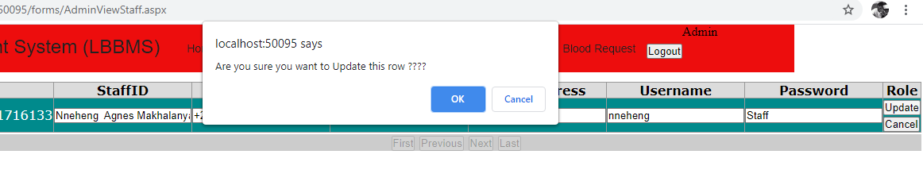

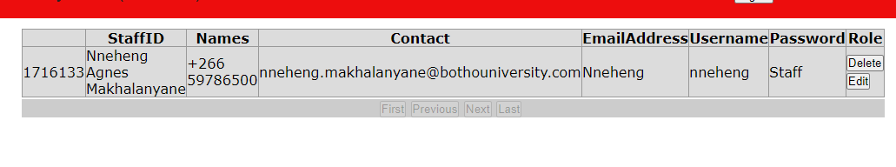

This screenshots show admin updating user details and he have to confirm that he wants to update the user. The update success as you can see user have a middle name but was not there when registering.

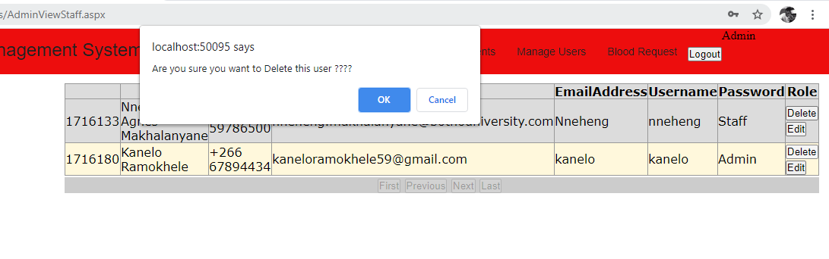

An admin is trying to delete a user in the database and he have to confirm the deletion.

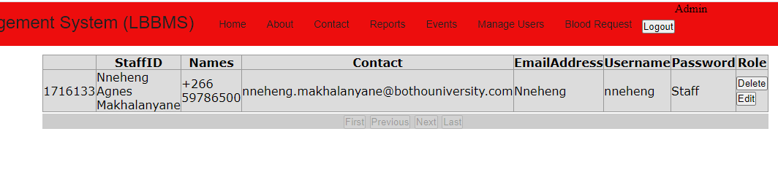

Here it shows that user successfully deleted.

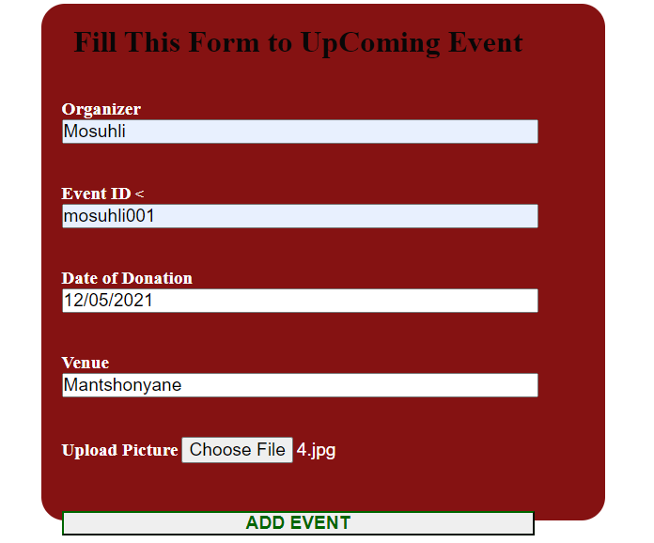

Here admin is adding an events and has to upload the picture for the place where events will take place.

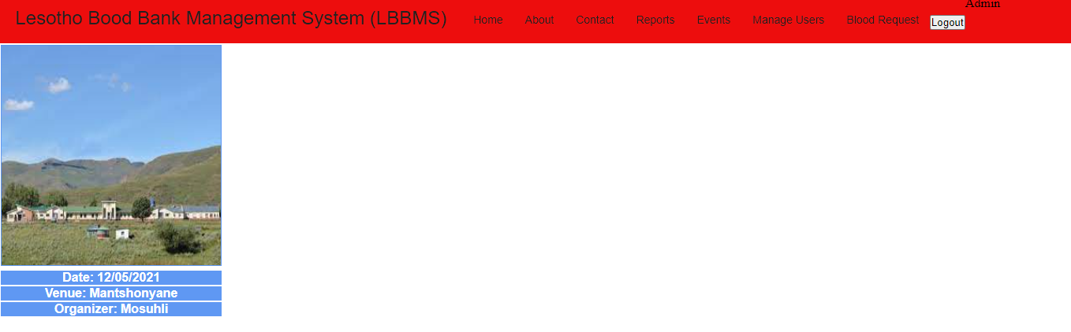

When user admin like to see upcoming events.

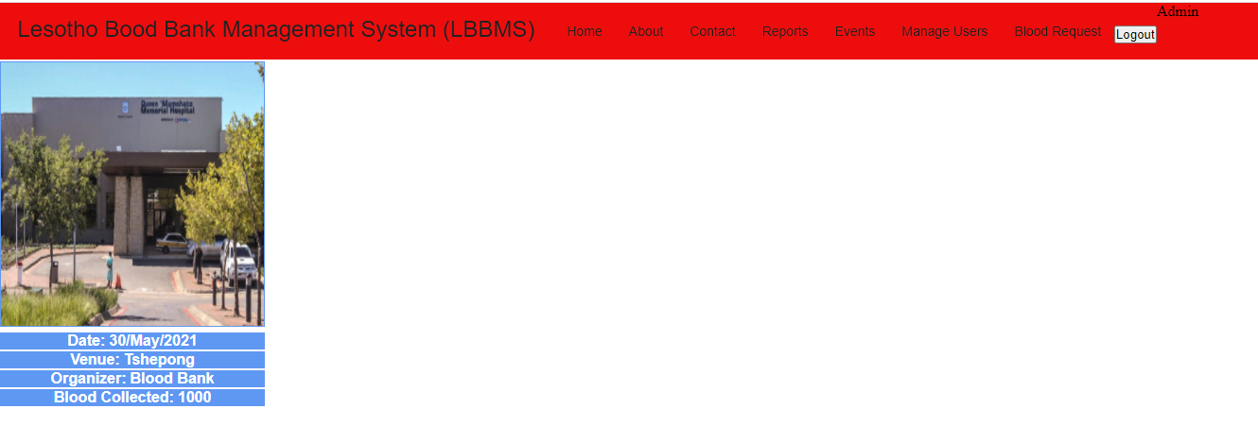

Here it’s the page for previews events.

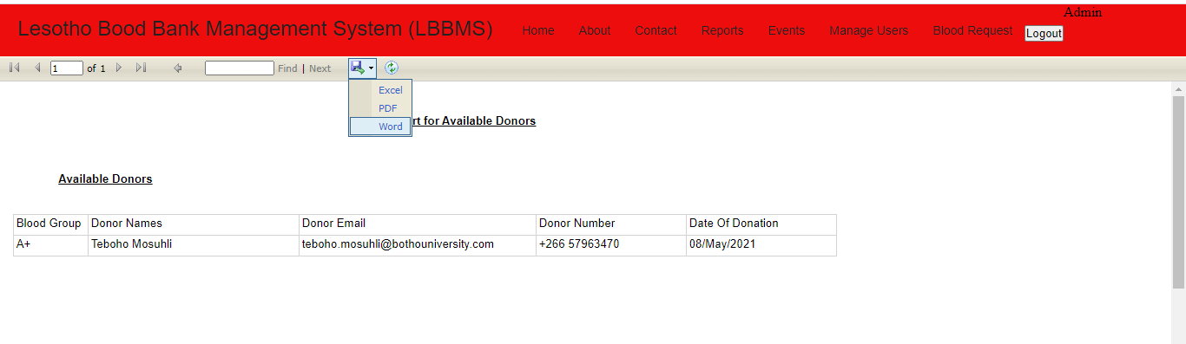

Admin can also generate reports, here is the report for available donors. The screenshot shows that he can download report as Excel, PDF or Word document.

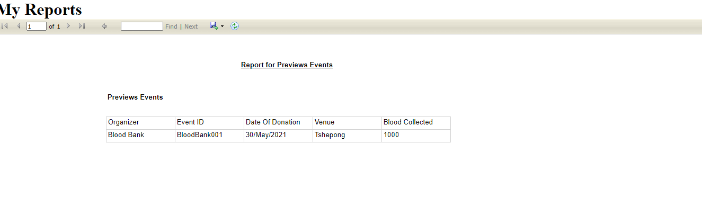

Here is the report for previews events.

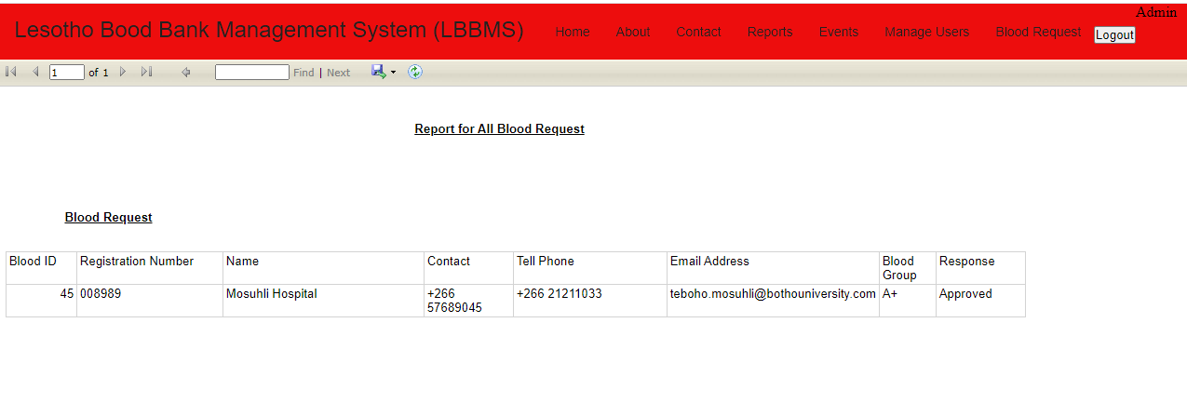

Here is the report for blood request.

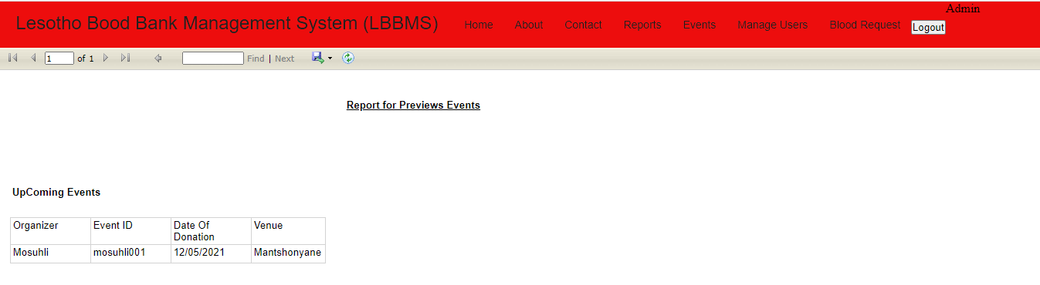

This is the screenshot for Upcoming events.

# 4.1.4 Staff

This part shows activities that user staff can do when logged in.

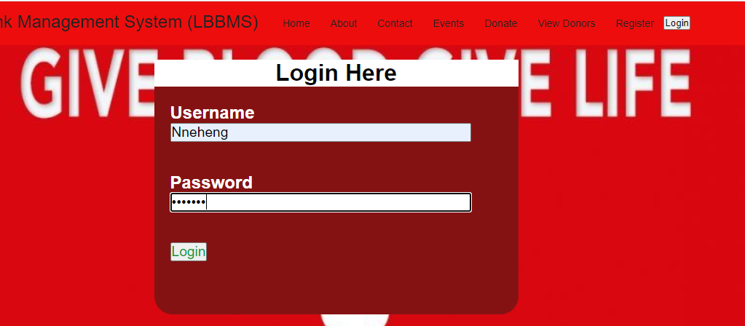

The user Nneheng was registered by admin and here she is logging in to the system. If the credentials are correct the user will be redirected to the staff home page but if the credentials are invalid the pop-up message will show and user will still be in login page as to re-enter credentials.

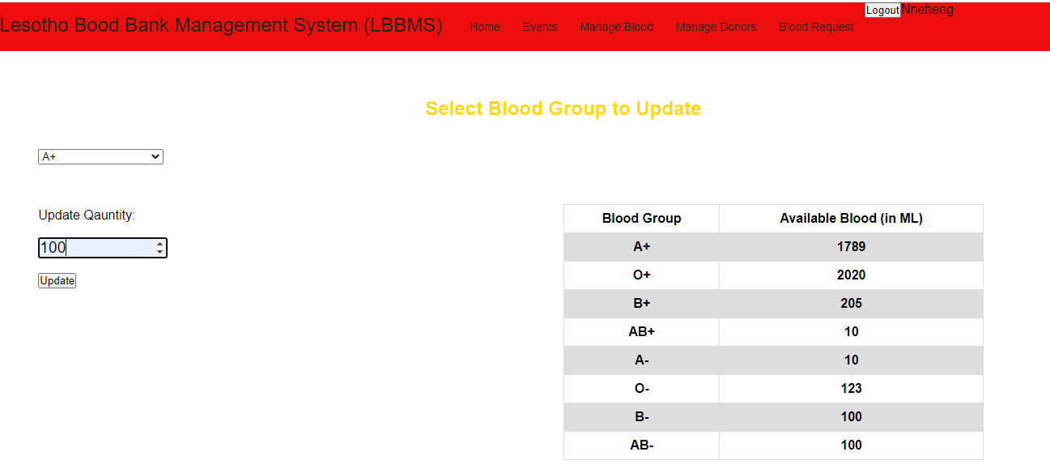

The users have logged in successfully, here the first task I showed above is when she is updating the blood, this happen when there is new blood coming in either from donation events or any donation. Here available blood in the store (for blood group A+) before update is 1789 and user is adding 100ML.

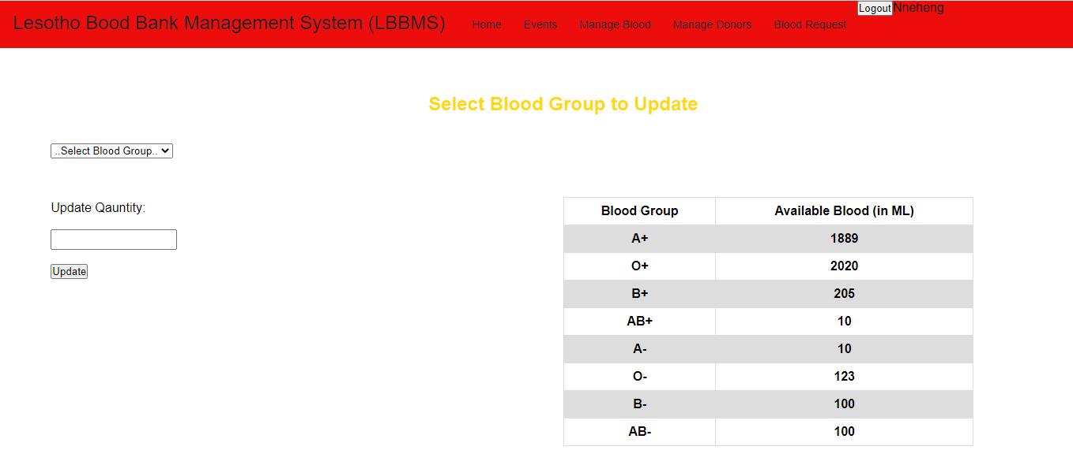

Update of blood group A+ success, and the quantity is now 1889.

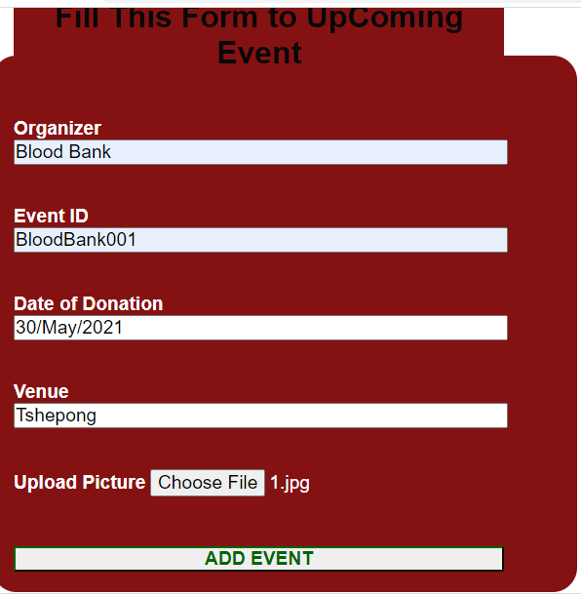

The second task the staff user is doing on above screenshot is adding events, if the its succeed the event should be visible in the upcoming events.

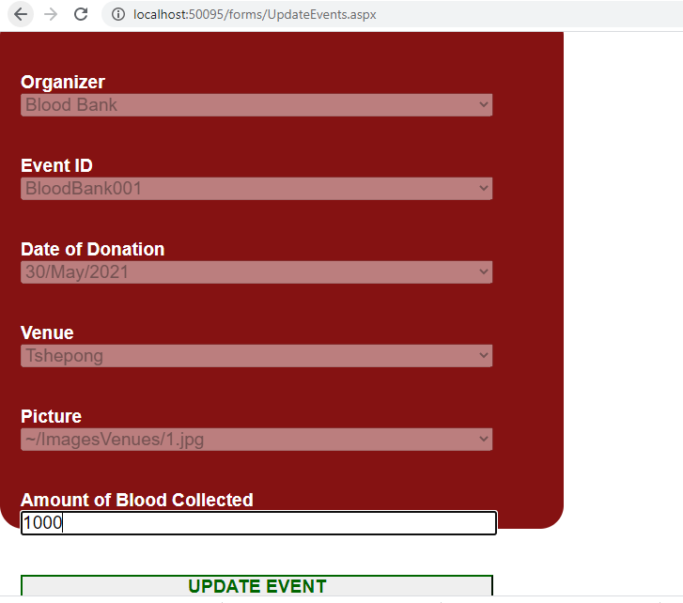

The user is updating the events and she should enter amount of blood collected from that event, and this event should now appear in the previews events.

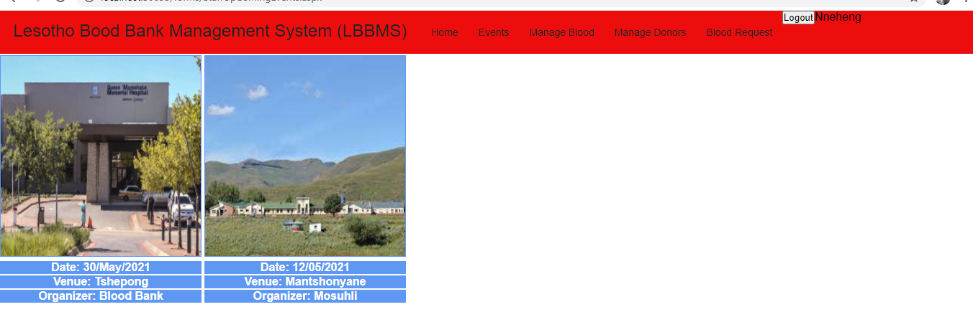

This shows upcoming events, it shows events date, venue, organizer and the picture of the place where event is taking place.

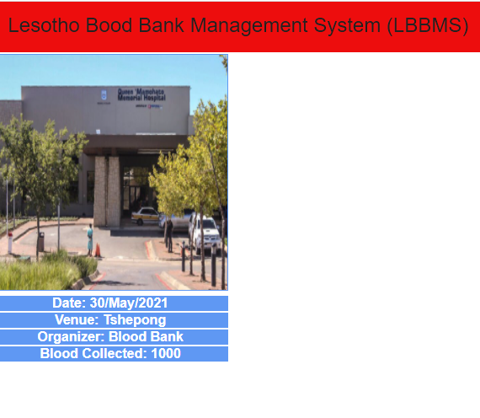

This shows previews event and the blood collected on that event.

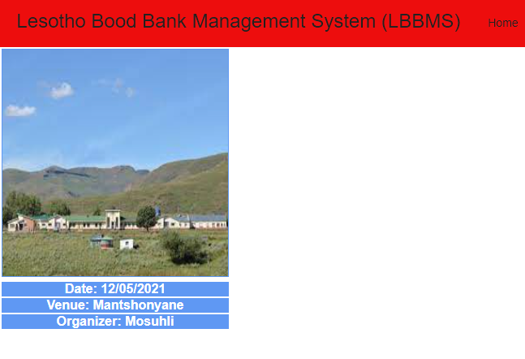

When user click on the upcoming events after updating events, it shows that one event is remaining.

## 4.2 Evaluation

This project went successfully because most of my project scope has went correctly. The project gave me an opportunity to design, code, and test and implement a web application using ASP.NET C#. In here I have learned how to use report view as for my system to generate reports. However, I have tried to generate report for available blood and it gives me problems because my data it’s an integer not string. Lastly the system should allow user admin to generate reports by entering date (from and to dates) but because of time I was not able to enter that parameters.

References

Ekanayaka, E. M. S. S. &. W. C., 2015. Blood bank management syste. *Technical Session-Computer Science and Technology & Industrial Information Technology,* Volume 7.

Esah, P. & Ab Rahman, S., 2011. *Blood Bank Management system.* [Online]   
[Accessed 19 March 2021].

Gaijjart, M. D., 2002. *Blood Bank Data Management System.* [Online]   
[Accessed 50 March 2021].

Khanter, A. V. J., 2009. Management information system application. *International Journal of Information System and Engineering,* Vol.3, No.1(April, 2015).

Mohammad, T. A., 2012. CBBR Centralized Blood Bank Repository. *International Journal of Information System and Engineering,* Vol.3(April,2015), p. 88.